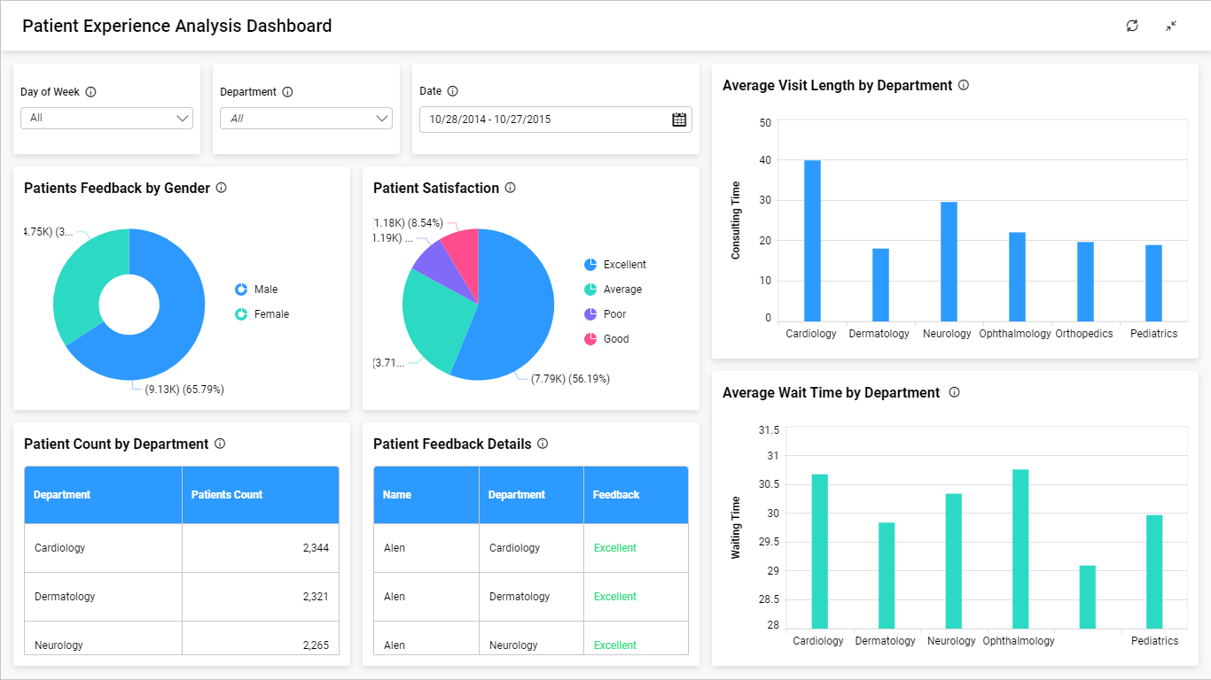

Good Morning Mr. Ali,

Hope you’re having a great day!

I would like to inform you that I reviewed our new healthcare dashboard the Patient Experience Analysis, which provides us a detailed breakdown of patients’ satisfaction with various hospital departments.

First of all I want to thank our team for the hard work, and I would like to say good job on some points:

1- The text and visualizations on your dashboard are all the same size, which is something important .

2- I have noticed that you put the highest level of data at the top left corner, and show more detail as you move in the direction the audience uses for reading.

3-Good choice on your visualizations it's easy to read and interpret, every charts showed its own data in a clear and understandable way.

4- The great thing is that you made the dashboard interactive by choosing a specific day, Department, or a date.

However, there are some things that need improvement:

1-You could have chosen another way to display the "Patient Feedback Details" sheet, more appropriately, for example: counting the number of comments in each department in order to show us which has the most positive comments and what is the worst to improve.

2- Same as the previous comment for the "Patient Count by Department" sheet, you should replace it with a bar chart or Pie chart to show the number of patients in each department in much clearer way!

3- In both "Patient Feedback by Gender" and "Patient Satisfaction" sheets, the numbers appear next to the percentage like(7.79k)(56.19%), it is difficult to read and unacceptable to the eye. It needs improvement.

4- In the "Average Wait Time by Department" plot, the Orthopedics department is missing.

In the end, I appreciate your work and thank you for choosing this dashboard, it contains important information because it provides insight into customer satisfaction. Moreover, it allows the hospital leadership to identify areas for improvement.

Thanks,

Yasmeen Aldossary